Document No.: Doc.Ref.: XXX
Version: 01
Date: [Publish Date]

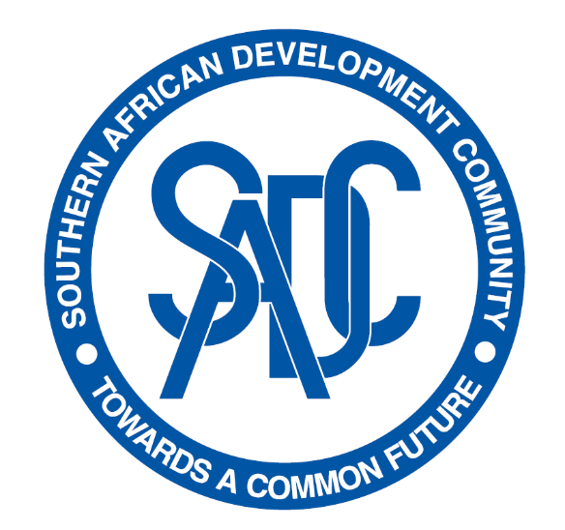
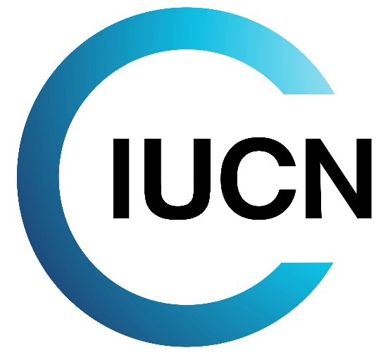

TFCA FF EXCLUSION LIST

Environmental and Social Management System
Doc.Ref.: XXX |  |  |  |  |  |  |  | Version: 01
TFCA FF EXCLUSION LIST
Issued on: |  | [Publish Date]
Current Version Approved by: XXX  Title: XXX  Date: XXX |  |  |  | Signature:
0 | XX/XX/2022 |  | SRA |  |  |  |  |  |  |  | First Draft
REV. | DATE |  | AUTHOR |  | CHECKED |  |  |  | APPROVED |  | MODIFICATION DETAILS
☐ | Confidential |  |  |  |  | ☐ | Internal |  |  |  | ☐ | Public

ACRONYM LIST
TERM | DEFINITION
CITES | Convention on International Trade in Endangered Species of Wild Fauna and Flora
EU | European Union
FPIC | Free, prior and informed consent
ILO | International Labour Organisation
IP | Indigenous Peoples
NTFP | non-timber forest products
PCBs | Polychlorinated biphenyls
SADC | Southern African Development Community
TFCA | Transfrontier Conservation Area
TFCA FF | Transfrontier Conservation Area Financing Facility
UN | United Nations
WHO | World Health Organisation

TFCA FF Exclusion List
The purpose of the Southern African Development Community (SADC) Transfrontier Conservation Area (TFCA) Financing Facility (FF) is to invest in tangible measures that strengthen ecological, economic, cultural, and institutional connectivity within SADC TFCAs for the management of shared natural resources and sustainable development. Hereby the Facility aims to contribute to the transboundary conservation of biodiversity and functional ecosystems as well as the sustainable use of natural resources to safeguard the vital socio-economic and ecological basis for the lives of the local population and future generations.
The Exclusion List of the TFCA FF is based on internationally recognised best practices exclusion lists for the conservation sector, including the exclusion list and sectoral guidelines as per KfW Sustainability Guideline (2022).
The TFCA FF will not finance any activities that involve the following:
- Activities and investments that could result in the impairment of areas particularly worthy of environmental protection, especially those that are legally protected, proposed for protection or identified as high conservation value;
- Infrastructure and equipment that would be considered defense dual-use investments that could be used for both conservation and military purposes;
- Commercial logging operations in primary tropical moist forest.
- The conversion of natural or high conservation value forests into plantation as well as the purchase of logging equipment for this purpose.
- Any extractive industry prospection, exploration and extraction activities in the coal, oil, gas, and mining sector as well as related transport means and infrastructure.
- Procurement or use of wood or other forestry products other than from sustainably managed forests.
- The unsustainable harvesting of natural resources -animals, plants, timber and/or non-timber forest products (NTFPs).
- Introduction of, or increased competitiveness of, invasive species.
- Unsustainable or destructive fishing methods in inland waterbodies, e.g., blast fishing.
- Production and purchase of and trade in weapons and munitions or critical components thereof.
- Production or trade in any product or activity deemed illegal under host country laws or regulations, subject to national or international phase-out or prohibition regulations or to an international ban, for example:
  - Certain pharmaceuticals, pesticides, herbicides, and other toxic substances (under the Rotterdam Convention, Stockholm Convention and World Health Organisation (WHO) "Pharmaceuticals: Restrictions in Use and Availability"),
  - Ozone depleting substances (under the Montreal Protocol),
  - Polychlorinated biphenyls (PCBs),
  - Protected wildlife or wildlife products (under Convention on International Trade in Endangered Species of Wild Fauna and Flora [CITES] / Washington Convention),
  - Prohibited transboundary trade in waste (under the Basel Convention).
- Harmful or exploitative forms of forced labour or harmful child labour as defined by International Labour Organisation (ILO) conventions.
- Procurement or use of any product or activity deemed illegal under host country laws or regulations or international conventions and agreements, or subject to international bans.
- Activities that infringe on the rights of indigenous peoples (IP).
- Activities that would result in involuntary physical displacement or forced eviction of people from their households, communities, territories, customary and ancestral domains⁵.
- Any activity leading to an irreversible modification or significant displacement of an element of culturally critical heritage⁵, or the use of any intangible cultural heritage without the free, prior and informed consent (FPIC) of the communities who it belongs to.
- Activities for the promotion of private sector commercial gain without links to community benefits, conservation, and development.
- Interventions to protect specific species or habitat types (e.g., deserts, forests) without reference to landscape connectivity.
TFCA FF will not finance projects, companies, activities, or individuals subject to United Nations (UN) or European Union (EU) sanctions. The Facility hence will not fund any activity or service subject to an embargo by the UN, EU and/or its funders in a particular country, including:
- Production or trade in radioactive material. This does not apply to the procurement of medical equipment, quality control equipment or other application for which the radioactive source is insignificant and/or adequately shielded.
- Production or trade in unbound asbestos. This does not apply to the purchase or use of cement linings with bound asbestos and an asbestos content of less than 20%.
- Production, use of, trade in, distribution or activities involving alcoholic beverages (excluding beer and wine), tobacco, gambling, casinos, and equivalent enterprises.
- Prospection, exploration, and mining of coal; land-based means of transport and related infrastructure essentially used for coal; power plants, heating stations and cogeneration facilities essentially fired with coal, as well as associated stub lines.
- Non-conventional prospection, exploration, and extraction of oil, such as from bituminous shale, tar sands or oil sands.

The stewardship and use of forests and forest lands in a way, and at a rate, that maintains their biodiversity, productivity, regeneration capacity, vitality, and their potential to fulfil, now and in the future, relevant ecological, economic, and social functions, at local, national, and global levels, and that does not cause damage to other ecosystems.
“Forced labour” means all work or service, not voluntarily performed, that is extracted from an individual under threat of force or penalty.
“Harmful child labour” means the employment of children that is economically exploitive, or is likely to be hazardous to, or to interfere with, the child's education, or to be harmful to the child's health, or physical, mental, spiritual, moral, or social development. Employees must be at least 15 years of age, as defined in the ILO’s Declaration on the Fundamental Principles and Rights at Work (C138 – Minimum Age Convention, Article 2), unless local laws require compulsory school attendance or a minimum working age. In such circumstances, the highest age requirement must be used.
The term “Indigenous Peoples” is used in a generic sense to refer to a distinct social and cultural group possessing the following characteristics in varying degrees as per WB Standard ESS 7: Self-identification as members of a distinct indigenous cultural group and recognition of this identity by others; Collective attachment to geographically distinct habitats or ancestral territories in the project area and to the natural resources in these habitats and territories; Customary cultural, economic, social, or political institutions that are separate from those of the dominant society or culture; An indigenous language, often different from the official language of the country or region.

